Final Year Project Report
On
AI Hitman Cloud-Integrated Sandbox Game



Submitted By
BSSE70169174 Muhmmad Abdullah
BSSE710169227 Hassan Saleh Hayat
In Partial Fulfillment of
The Requirements for the Degree of
Bachelor of Science in Software Engineering

Supervised by: Mam Sana Fatima

Department of Computer Sciences
University of Lahore, Sargodha Campus
Session: 2022-2026
Final Approval

This project titled

“AI Hitman – Cloud-Integrated Sandbox Game”

By

Muhammad Abdullah
70169174
Hassan Saleh Hayat
70169227

Has been approved for the
Department of Computer Sciences,
University Of Lahore (Sargodha Campus)

External Examiner:______________________________________________________________
Sir Yasir
Lecturer
The University of Lahore
Sargodha

Supervisor: _____________________________________________________________________
Mam Sana Fatima
Lecturer
The University of Lahore
Sargodha

FYP Committee Head: ___________________________________________________________
Ms. Fatima Iqbal
Lecturer
The University of Lahore
Sargodha

HoD: __________________________________________________________________________
Dr. Suleman
Professor
The University of Lahore
Sargodha

Declaration

I/We hereby declare that this work, neither as a whole nor as a part there of has been copied out from any source. No portion of the work presented in this report has been submitted in support of any application for any other degree or qualification of this or any other university or institute of learning.

_________________________
Name: Muhammad Abdullah
Reg: 70169174
Name: Hassan Saleh Hayat
Reg: 70169227

Dedication

We want to dedicate our project to out parents. They have been supporting and believing in us. If they were not with us, we would never been able to achieve this success.

We also want to appreciate our supervisor, Mam Sana Fatima, she has been supporting us with her knowledge, experience and patience. Her guidance has improved our technical skills and the importance of patience and hard work.

And, to our friends and classmates who have been with us since day one giving their support and technical knowledge. Their support has been a very motivational stone for us

And at the last we want to dedicate our project to all those developers who are still on their learning phase and have interest in AI, Cloud Computing and Unity. This project will be help for them to understand the practical working and know that the world of creativity has no limits.

Acknowledgement

We express our deepest thanks from the bottom of our heart to Allah Almighty for giving us the knowledge and power to complete our project.

We are also very thankful to our supervisor Mam sana Fatima for her continues support and teaching that helped us to successfully complete our project. Without her guidance this would not have been possible.

We also express our thanks to our department of Computer science for providing us with the resources and the environment that were needed to achieve successful completion of our project. And to the faculty for motivating us.

A very big thanks to our families for always supporting us and always believing in us. Their support and believe made us what we are today and motivated us to push our limits.

Table of Contents

Final Year Project Report 1
Chapter 1: Introduction and Background 8
1.1 Statement of Problem Area 9
1.2 Background History 9
1.3 Previous and Current Work 10
1.4 Project Description 10
1.5 Purpose and Objectives 10
1.6 Scope 11
1.7 Tools and Technologies 11
1.8 Deployment Platform 12
1.9 Project Scheduling 12
Chapter 2: Software Requirements Specifications 14
2.1 Functional Requirements 15
2.2 Nonfunctional Requirements 16
2.3 Feasibility Analysis 17
Chapter 3: System performance Requirements 20
3.1 Efficiency 21
3.2 Reliability 21
3.3 Security 21
3.4 Maintainability 21
3.5 Modification 22
3.6 Portability 22
Chapter 4: System Analysis & Design Overview 23
4.1 Use Case Diagram 24
4.2 Software Process Model 24
4.3 Data Model 25
4.3.1 Entity Relationship Model 25
4.3.2 System Data Dictionary 25
4.4 Behavioral Models 26
4.4.1 Data Flow Model 26
4.4.2 System Sequence Model 27
4.5 Object Models 28
4.5.1 State Model 28
4.6 Implementation Languages 29
4.7 Required Support Software 30
Chapter 5: User Interface Design 31
5.1 User Interface Specification 32
5.1.1 User Interface Design 32
5.1.2 Report Format/Sample Data 32
5.2 User Support 33
5.2.1 Online Help material 33
5.2.2 Error Conditions and System Messages 33
Chapter 6: System Verification & Validation 34
6.1 Items and Functions to be Tested 35
6.2 Description of Test Cases 35
6.3 Justification of Test Cases 36
6.4 Test Run Procedures and Results 37
Chapter 7: Conclusions 39
7.1 Summary 40
7.2 Problems Encountered and Solved 40
7.3 Suggestions for Better Approaches 41
7.4 Suggestions for Future Extensions 41
Bibliography and References 43

Chapter 1: Introduction and Background

1.1 Statement of Problem Area

A very common problem encountered with most of the gaming experiences is the lack of NPC intelligence and behavioral diversity. Conventional characters in games rely on coded behaviors and finite automaton machines, which provide foreseeable patterns that make the games less enjoyable to the players. The training of single AI models of multiple NPCs is computationally expensive enough to be limited to academic research and individuals.

Moreover, the modern games can hardly show us the successful collaboration between machine learning systems and cloud infrastructure. This loophole is characterized by a missed content delivery dynamic, continuous analytics, and scalable AI implementation. The industry needs the real demonstration of how the reinforcement learning may be effectively used to make different NPC behaviours and ensure the appropriate responsibility of the clouds on model control and the player data synchronization.

In this project, we tackled these challenges by using a unique method which is to use reinforcement learning to train one NPC agent and then replicate it with various modifications so that they generate behavioural heterogeneity. AWS enables cloud integration, which enables the storage of models centrally, the use of the real-time leaderboard, and displays the current distributed system architecture that can be used in commercial gaming.

1.2 Background History

Evolution of Game Artificial Intelligence

Game AI has evolved so much since early implementations in chess programs during the 1950s. With the development of computing power, more and more advanced methods, starting with simple rule-based systems and ending with modern machine learning methods (Russell and Norvig, 2020). In the 1990s, finite automation machines reached industry standard, driving NPC behaviour.
in such successful series as Half-Life and The Sims (Millington & Funge, 2009).

Machine Learning in Gaming

The introduction of machine learning in the gaming industry has been accelerated by the discovery by DeepMind of the ability to teach neural networks to master Atari games by using reinforcement learning (Mnih et al., 2015). This study presented the fact that agents were able to acquire complicated tactics by interacting with the environment instead of script programming. These methodologies are illustrated in Unity Technologies where ML-Agents were launched in 2017, an open-source toolkit that enables users to apply reinforcement learning without expert knowledge (Juliani et al., 2018).

The modern RL algorithms, such as Proximal Policy Optimization, have demonstrated excellent performance when training game agents (Schulman et al., 2017). The newest recent success is the OpenAI Dota 2 bot and the DeepMind StarCraft II agent, which display the power of RL in complex games changing environments (Vinyals et al., 2019).

Cloud Computing in Gaming

The cloud infrastructure revolutionized the creation and release of games. Such platforms as AWS have scalable services of data management, content delivery, and backend processing. Educational projects, in particular, can enjoy the strong resources of the AWS Free Tier, without any restriction to the financial potential. Cloud use in online features, community and analytics and MMORPGs continues to expand. By the fact that successful implementations have been made in large games such as Fortnite and Apex Legends, you can guess it.

1.3 Previous and Current Work

The research work in the academic field mostly focuses on reinforcement learning in simulated environments. Theoretical frameworks have been developed by Sutton & Barto (2018), and agents have been trained in Unity ML-Agents to navigate, fight, and cooperate. Across industry applications (which are frequently proprietary), adaptive AI use is growing.
However, the majority of the existing solutions tend to be dedicated to either AI training or cloud infrastructure, and rarely show full integration. Besides that, using a different model for each NPC type consumes significant computational resources. With high-quality research combined with practical feasibility, this project introduces a methodology that is both resource efficient and based on the training of one model and generating diversity through parameter variation.

1.4 Project Description

AI Hitman presents a 3D sandbox with intelligent NPCs surrounding players and engaging in combat in dynamic situations. The innovation is that a single master NPC learns strategies for combat using reinforcement learning and that this learned intelligence is replicated in different game characters. Differences in the various parameters such as movement speed, reaction time, visual detection range, combat accuracy, etc. condition the different encounters with a trained model, which are present in each duplicate.
AWS cloud services provide back-end infrastructure. The model trained is stored in Amazon's S3 storage where it can be version controlled and updated remotely. Data operations are performed by Lambda functions, and player statistics and leaderboard data can be stored in DynamoDB. API Gateway enables cloud services to communicate with the Unity client, demonstrating modern distributed architectures patterns that could be used in commercial applications.

1.5 Purpose and Objectives

There are several objectives with this project: industry level technical skills, resource efficient methods of NPC diversity, and a demonstration of a practical implementation of AI, game development and cloud computing. This work deals with educational objectives and implementation issues.

Primary Objectives:
- Create a 3D sandbox environment that is interactive and has player control and capturing combat.
- To train one NPC agent via reinforcement learning via Unity ML-Agents, showing adaptive behaviour adoption
- Install smart duplication system that generates behavioral variation by parametric variation.
- The integration AWS services (S3, DynamoDB, Lambda, API Gateway) to store storage and model data and management of data
- Develop Player stats system that is synchronised with each game session stats

Secondary Objectives:
- To show the expertise in different areas of software engineering
- Write in-depth documentation that is readable by academicians and technocrats
- Maximize the use of system resources in the hardware and cloud service limits
- Systemic testing – Verify functionality

1.6 Scope

The project demonstrates the creation of the 3D environment, player control, NPC reinforcement learning in the form of AI training, use of cloud services. The general scope does not cover any complicated mission architectures, multiplayer networking, mobile, and commercial-grade graphics. The Windows PC is the main target of development, and the implementation is planned to be kept free of cost with the help of AWS Free Tier.

Weaknesses are AWS service caps in the free tier, basic gameplay where technical display is prioritized over gameplay challenging, and single platform implementation. The limitations guarantee project viability within the academic timeline phase and resources and preserve technical domain.

1.7 Tools and Technologies

Game Development Stack

The main development platform is Unity 3D (2021.3 LTS), which we choose because of its excellent 3D support, in depth documentation, and the presence of ML-Agents. C# scripting has an integrated development environment in visual studio 2022. Blender is used optionally in asset creation custom 3D modelling needs.

Machine Learning Infrastructure

Unity ML-Agents Toolkit (Release 20) makes it possible to conduct reinforcement learning, in particular, to apply Proximal Policy Optimization to train agents. It requires a Python 3.9+, PyTorch 1.13+ environment with which the neural networks can be worked withGoogle Colaboratory provides training on GPUs in case if we need if local resources are not enough

Cloud Services Architecture

AWS does provide us with infrastructure in the Free Tier. S3 is used to store object models that are under training, DynamoDB is used to store NoSQL object models of player statistics and Lambda is a serverless compute service, and API Gateway is a REST exposer. contact points with the clients. Unity integration is supported by AWS SDK of .NET.

Development Tools

Git and GitHub are used to control version and code repository. ML-Agents python training scripts are supported with the aid of Visual Studio Code. Postman will allow API endpoint validation and testing. AWS Management Console is a cloud resource web-based administration.

1.8 Deployment Platform

Windows 10/11 systems with minimum requirements, including Intel Core i5 processor, 8GB RAM and dedicated graphics cards (GTX 1050 or similar) are under development. Unity 2021.3 LTS with integration of ML-Agents toolkit. Python environment via anaconda will do the management of ML-Agents.

Both local and cloud-based option is supported by training environment in Google Colaboratory where the use of the GPU acceleration is vital. The cloud infrastructure will be deployed to AWS US-East-1 region under Free Tier services with monitoring to avoid excessive costs.

Security configuration implements IAM roles with least-privilege access, API key authentication for Unity clients, and HTTPS encryption for all cloud communication. DynamoDB access restricts through role-based permissions, preventing unauthorized data access.

1.9 Project Scheduling

The 12-week development schedule structures work into seven different phases:

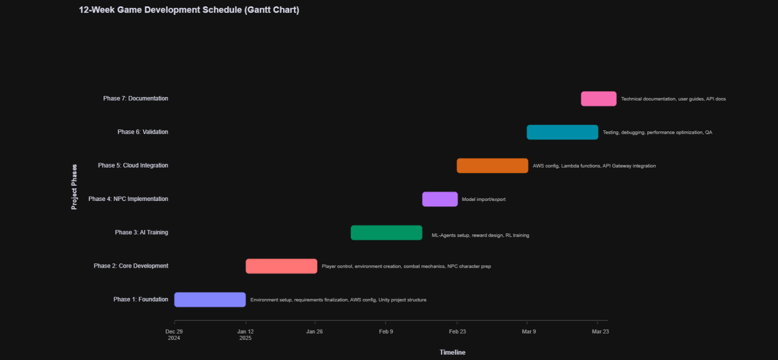
Figure 1Project Scheduling

Chapter 2: Software Requirements Specifications

2.1 Functional Requirements

FR1: Player Control System

Player control is responsive with WASD keys allowing easy movement, and varying speed with the Shift key, when running. The camera can be oriented using mouse inputs with adjustable sensitivity. Methods of combat involve using the left mouse button to shoot, right mouse button to aim and visual crosshair feedback. Responsive and smooth physics-based movement makes for responsive gameplay, with the ability to jump using Spacebar.

FR2: NPC AI System

Position, NPC health bar, distance and sightline determination are captured in the reinforcement learning training environment. Agent actions are those like movement, rotation, shooting and taking cover. The damage dealt (positive) is rewarded, the damage received (negative) is punished, and the survival time rewards are given. Training uses proximal policy optimization algorithm until the combat performance is good enough.
The NPCs we will be training will be able to detect players within calculated vision ranges, move around obstacles in the environment, will join in tactical combat, will respond to damage by reducing health and will respawn on elimination. On the one hand is the duplication system which creates multiple instances of the base model with varying values of the parameters. The parameters vary from speed of movement (0.8x-1.2x multiplier), reaction time delay (0.1s-0.5s), vision range difference (15m-25m), shooting accuracy difference (50%-90%) and health point difference (80-120 HP).

FR3: Combat and Interaction Systems

The damage in range based combat is determined when the target is hit. Player and NPCs have HP which decreases due to damage. When someone uses up their health, they are eliminated from their character. If available, the UI will display real-time health indicators, current score display, aiming crosshair, and ammunition counters.

FR4: Cloud Integration

The trained model will be uploaded onto AWS S3 with versioning enabled for the updates to be remote for the clients without changing the model. DynamoDB will have three tables: PlayerStats containing PlayerID, Score, Kills, Deaths and Timestamps; Leaderboard containing Rank, PlayerName, and Score values; and finally, NPCVariations containing NPCID and configurations of parameter. The Lambda function will be used for the actions of UpdateLeaderboard, GetPlayerStats, and FetchNPCModel, with requests being completed within 3-second time limits. API Gateway exposes REST endpoints for communicating with Unity-AWS with JSON response formatting and authentication using API keys.

FR5: Game Session Management

Score tracker will accumulates scores for killing NPCs and for surviving. The session statistics will include gameplay time, kill count, death count and percentage accuracy. Once the session is completed, the data will be stored in the cloud. Player will be able to post scores to the public leaderboard. Top 10 players on the leader board will show their rank, name and score information and it will refresh in real time or when requested.

2.2 Nonfunctional Requirements

NFR1: Performance Specifications

The app will be supporting at least 30 frames per second on target hardware; it will be aiming at 60 frames per second on recommended hardware. Performance optimization will be enabled by frame rate degradation under 25 FPS when most active. The input latency will be less than 100 milliseconds with a processing response of the NPC decision making taking less than 200 milliseconds. The normal network conditions will allow completing cloud API requests in less than three seconds. The memory consumption limit will be 4GB RAM, graphics usage will not exceed 80 percent on suggested hardware, and overall size of the build will not exceed 500MB.

NFR2: Reliability and Stability

Exception handling will ensure that the system does not crash when playing the game normally. Information security will ensure that the information about the players is not corrupted or lost. Atomic operations that will be used to achieve consistency will be done on leaderboard updates. The control of network failure will consist of automatic retries (up to three attempts) with clear feedback to its user. The system achieves 99% uptime during testing phases.

NFR3: Security Measures

AWS API requests will require secure authentication through managed API keys, it’ll be never exposed in client code. All cloud communication will use HTTPS encryption. Player data collection will not have personally identifiable information. leaderboard will enter player’s data using their chosen usernames. DynamoDB access will be restricted using IAM role configuration. Input validation sanitizes all user entries that will prevent injection attacks.

NFR4: Usability and Maintainability

If we have a proper good UI design, then it will be readable and intuitive interaction after the established games events. Control schemes will be similar to industry standards, so that you can have an understanding of the basic mechanics within 5 mins. There will be visual and audio feedback to give immediate affirmation for responses. The coding will adhere to C# and Python coding conventions, and be well commented and organized into functions to help understand the code. Technical documentation will enable replication of the project and Git version control will keep a history of the project's development with descriptive commit messages.

2.3 Feasibility Analysis

2.3.1 Technical Feasibility

All the technologies that are required Unity 3D, ML-Agents toolkit, AWS Free Tier services, Python, and PyTorch are freely accessible with comprehensive documentation. The members of the team possess background in the academic research on software engineering, artificial intelligence, and cloud computing. Extensive online materials, guides and support groups give solutions to challenging implementations. Issues such as reinforcement learning issues, the complexity of the integration of AWS, and long training times have shown mitigation approaches: adhering to existing examples of the ML-Agents framework, independently testing cloud services, and making use of Google Collaboratory GPU acceleration.

2.3.2 Operational Feasibility

The system will be compatible with the normal windows PC environments and it will not have any special hardware needs. The controls will be of the standard gaming style with minimum training on the user. Cloud backend is transparent in nature, and it takes care of the infrastructure maintenance automatically. AWS services will manage scaling and availability, that’ll eliminating manual server administration concerns. Game updates will be deployed via executable replacement, while model updates will be pushed to S3 without client modifications. Basic in-game instructions will be enough for player onboarding, with comprehensive documentation available for technical users.

2.3.3 Legal and Ethical Feasibility

All development tools maintain proper licensing for educational use. That includes Unity Personal Edition, ML-Agents toolkit, Python, PyTorch, and AWS Free Tier clearly permit academic projects. No copyrighted assets or intellectual property violations will be occurred. The project remains non-commercial, preventing any licensing complications. Game content avoids too much violence or unethical mechanics. Data collection maintains minimizes scope, collecting only anonymous gameplay statistics. No personally identifiable information gathering will happen, maintaining privacy compliance. AWS usage adheres to terms of service, hosting only appropriate content.

2.3.4 Economic Feasibility

Development costs remained zero. Unity Personal Edition, ML-Agents, Python ecosystem, AWS Free Tier, and Visual Studio Community Edition all gives free access for educational purposes. AWS Free Tier offers: 5GB S3 storage with 20,000 GET and 2,000 PUT requests monthly; 25GB DynamoDB storage with 25 read/write capacity units; 1 million Lambda requests with 400,000 GB-seconds compute monthly; and 1 million API Gateway calls monthly. All the expected usage remains well within these limits: models consuming around 100MB storage, player data requiring about 1MB database space, and testing generating 1,000-5,000 API invocations. Cost-benefit analysis shows zero financial investment yielding considerable educational value, improved employability, advanced technical skills, and will strengthen the portfolio.

2.3.5 Schedule Feasibility

The 12-week schedule allows: two weeks on planning and setup, two weeks on core game development, two weeks on AI training, one week on NPC implementation, two weeks on cloud integration, two weeks on testing and optimization, and one week on documentation. This distribution provides enough time for each phase with built-in buffer periods. Timeline realism comparison to similar academic projects To validate timeline realism normal game development capstones last between 10-14 weeks, with ML-Agents projects lasting between 4-8 weeks, and cloud integration projects lasting between 6-10 weeks. The coordination of tasks among the team members increases the efficiency in the schedule and parallel documentation during the development.

2.3.6 Motivational Feasibility

Team members show real enthusiasm for fields like AI, game development, and cloud computing. This project mixes solid theory with actual hands-on work, and it creates real results you can play and see. Learning chances here cover top industry skills in reinforcement learning, building with Unity, and designing AWS setups. Adding the project to a portfolio boosts its strength a good deal. It highlights competence across several domains at once. The whole thing ties right into positions in game development, AI engineering, and cloud architecture. Technical challenges give intellectual engagement while problem solving builds professional skills. Clear role division (cloud/AI versus game development) with collaborative integration points provides effective teamwork.

2.3.7 Information Feasibility

The resources support all project components. Unity documentation at docs.unity3d.com provides comprehensive references that have thousands of tutorials available on YouTube and educational platforms. Unity ML-Agents GitHub repository has examples, documentation, and sample projects. AWS documentation thoroughly covers all utilized services with step-by-step integration guides. Academic papers including Sutton & Barto's reinforcement learning textbook, Mnih et al.'s DQN research, and Schulman et al.'s PPO algorithm documentation establish theoretical foundations. Community resources through Stack Overflow, Reddit, and Discord channels provide troubleshooting assistance. Supervisor support through Mam Sana Fatima offers additional guidance that you need.

2.3.8 Specification Feasibility

Project requirements show clarity, completeness, and achievability. Functional requirements state observable behaviours with strong implementation paths. Non-functional requirements make measurable performance criteria. Objectives are aligned with academic evaluation standards while maintaining industry relevance. Scope strongly defines inclusions and exclusions, preventing scope creep. Requirements are divided into manageable components executable within the schedule limitations. There are no requirements that depends upon the technologies that are unavailable or exceed resource capabilities. Verification methods exist for all requirements functional requirements are measured by gameplay testing, non-functional requirements are measure by quantitative metrics, and cloud integration confirms through API testing.

Chapter 3: System performance Requirements

3.1 Efficiency

The AI Hitman system is developed keeping efficiency as a central focus throughout the system. Unity game engine is designed to run at no less than 30 frames per second on suggested hardware (Intel core i5, 8GB RAM, GTX 1050) and can hit 60 frames per second on more powerful machines. The zombie AI implemented with FSM uses the built-in NavMesh system of Unity as an efficient pathfinding algorithm that does not require any extra overhead to calculate the routes. The Reinforcement Learning aspect is confined to move decisions of the NPCs. This controlled scope limit is to make sure that the computationally more expensive inference operations do not become a bottleneck of game performance. The trained ML-Agents model does forward passes at every decision step, and as movement outputs are only used, the neural network is lightweight and fast. On the cloud side, the Flask REST API is implemented on AWS Lambda which provides almost instant cold-start performance at infrequent load and close to zero latency at warm load.

3.2 Reliability

Multi-layers of fault tolerance are used to guarantee system reliability. The Unity game manages exceptions locally such that a failure on the cloud API does not cause the game session to crash. It has a local cache of session data which is retried three times and then discarded, so that gameplay is not interrupted by a poor network connection. AWS Lambda offers built-in high availability with automatic inter-availability zone redundancy. DynamoDB has a 99.999% availability with multi-AZ replication. The RL component only adds to movement, and thus although the ML model may yield unforeseen results, the FSM will block all essential state transitions.

3.3 Security

The security is applied on game client and cloud infrastructure. The user AWS IAM adheres to the principle of least privilege, which is limited to AdministratorAccess to the project resources only. The Flask API deployed on Lambda does not embed any credentials in its code; all authentication by AWS is done by IAM role assignment at the Lambda function level. The RL model is stored in the S3 bucket under a public read bucket policy where the bucket policy only allows the GET object operations. Anonymous users are not given write access. The sole interface to DynamoDB is the Flask API and the Unity client never has direct access to it. All API communication is over HTTPS via AWS API Gateway, and all data is encrypted when it is in transit. The data of the players is anonymous, with only the statistics of the gameplay (kills, health, weapon, session time) being recorded and no personal information.

3.4 Maintainability

There is separation of concerns in the codebase. The Flask API has five well-documented endpoints, each having a single responsibility. Infrastructure refers to the piece of code written in Terraform that describes all the AWS infrastructure that can be built up again with a single terraform apply command. Deployment is automated. The Unity game splits the FSM logic, integration of RL and cloud communication into separate C# scripts. Cloud Manager script manages all Http communication with the API, leaving game logic uncontaminated. All non-evident logic is documented in code comments and Git version control keeps the entire development history.

3.5 Modification

The system architecture will be so made, that it can be modified in the future with minimum effects. New API endpoints are easy to add, we just need to add a new route to app.py and redeploy. Adding new dynamoDB attributes do not require any schema migration, since the DynamoDB is a schemeless database except in the primary and sort keys. The RL model can be retrained and uploaded to S3 without any modifications to the Unity client, since it loads the model URL dynamically over the /get-model-URL endpoint. New state classes in Unity can be added to the FSM, without any changes to existing transitions. Terraform parameters change The Terraform variables.tf file enables changing of infrastructure parameters, like region and bucket name, centrally, and automatically propagating to all resources depending on them.

3.6 Portability

The game client will be based on Windows 10/11 as the main platform and Unity cross-platform build system. The cloud backend is completely platform-neutral, being implemented on AWS Lambda using Python 3.8 as runtime. The site dashboard is a simple HTML file in S3 and can be accessed anytime and anywhere in any browser with the help of the public URL. The definition of Terraform infrastructure is conceptually cloud-portable but is currently set up on AWS US-East-1. The change in migration to another AWS region is as simple as changing the aws region variable. Flask API does not have platform-specific dependencies and relies on standard Python libraries (Flask, boto3).

Chapter 4: System Analysis & Design Overview

4.1 Use Case Diagram

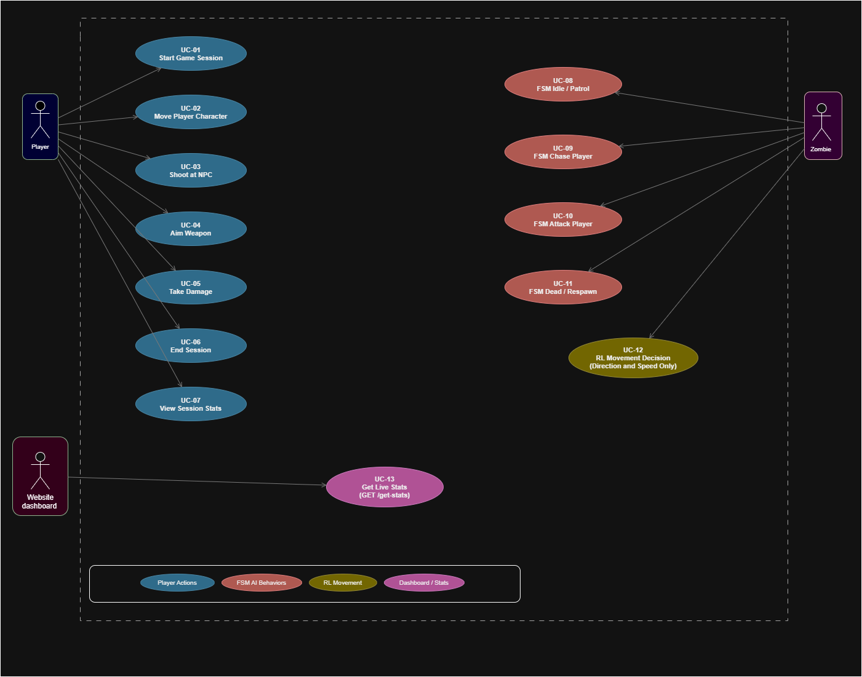
Figure 2 Modular Use Case Diagram

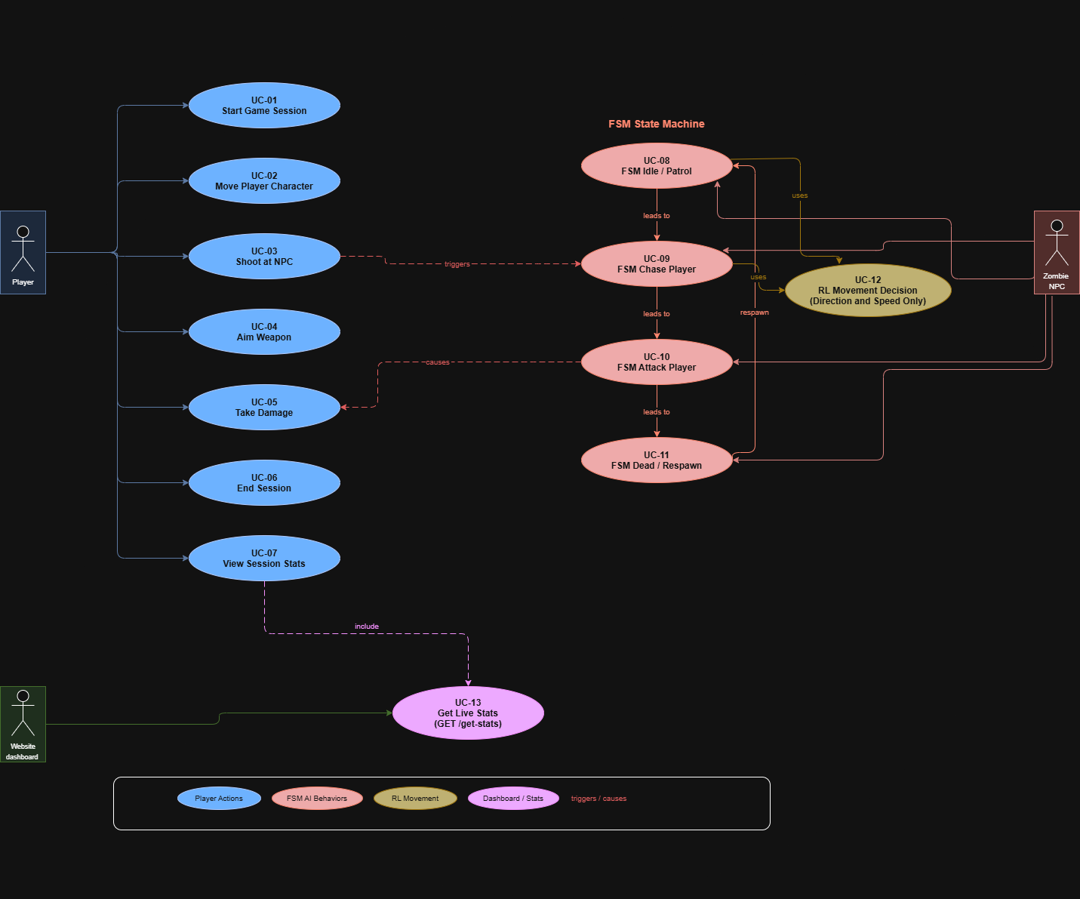
Figure 3 System-Level Use Case Diagram

4.2 Software Process Model

The project is based on an Incremental Development Model, which was selected due to the possibility to independently develop and test separate aspects and then incorporate them. The following increments were arranged with regards to the development:
Increment | Phase | Components Delivered | Duration
1 | Core Game | Unity 3D environment, player movement, basic combat, camera system | 2 weeks
2 | FSM AI | Zombie NPC, NavMesh, Idle/Patrol/Chase/Attack/Dead states | 2 weeks
3 | RL Integration | ML-Agents training setup, RL movement component added to FSM zombie | 2 weeks
4 | Cloud Infrastructure | Terraform: S3 + DynamoDB, Flask API with 5 endpoints, Lambda deploy via Zappa | 2 weeks
5 | Integration & Testing | Unity-API integration, end-to-end testing, bug fixes | 2 weeks
6 | Dashboard & Docs | S3-hosted site with live statistics, final documentation | 2 weeks

4.3 Data Model

4.3.1 Entity Relationship Model

The data model of the system is represented by two main entities that are controlled in AWS DynamoDB and one stored artifact in AWS S3:

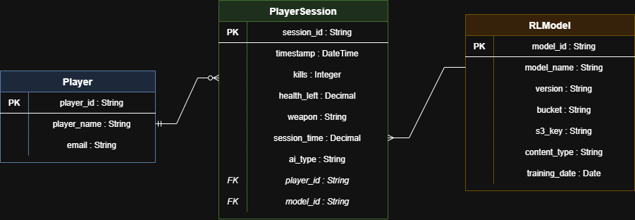
Figure 4 Entity Relationship Model Diagram

4.3.2 System Data Dictionary
All data fields in the PlayerSession entity in DynamoDB are defined in the following table:

Field Name | Data Type | Constraints | Description
player_id | String | Required, Primary Key | The player identifier, which is provided by Unity client
timestamp | String | Required, Sort Key | ISO date time when session was stored
kills | Number (Integer) | Required, >= 0 | Number of zombie NPCs that were killed during the session
health_left | Number (Decimal) | Required, 0-100 | Percentage of player health remaining at the end of the session
weapon | String | Required | Name of weapon used during the session
session_time | Number (Decimal) | Required, > 0 | Total session time (in seconds)
ai_type | String | Optional, default: FSM | Type of AI active: FSM or RL

4.4 Behavioral Models

4.4.1 Data Flow Model

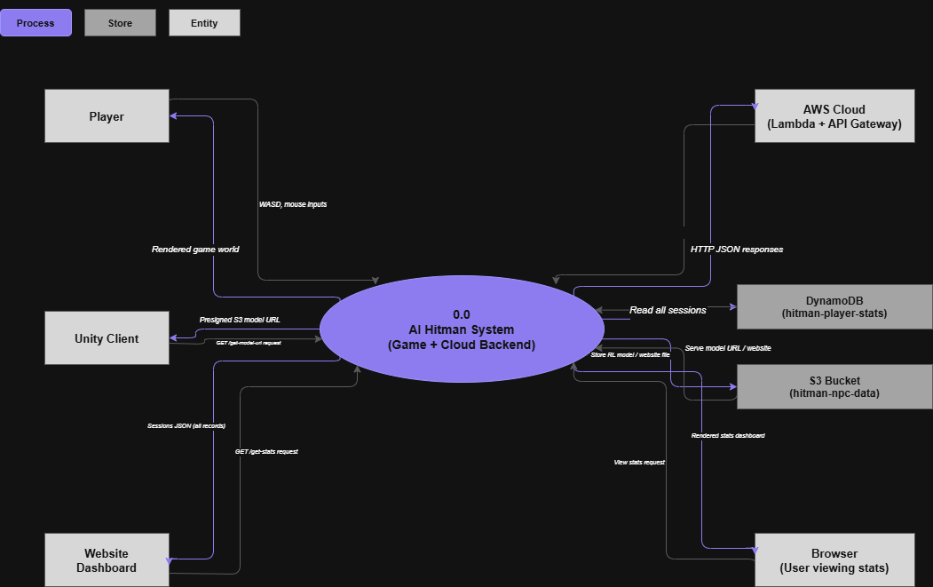
Figure 5 0-level Data flow diagram

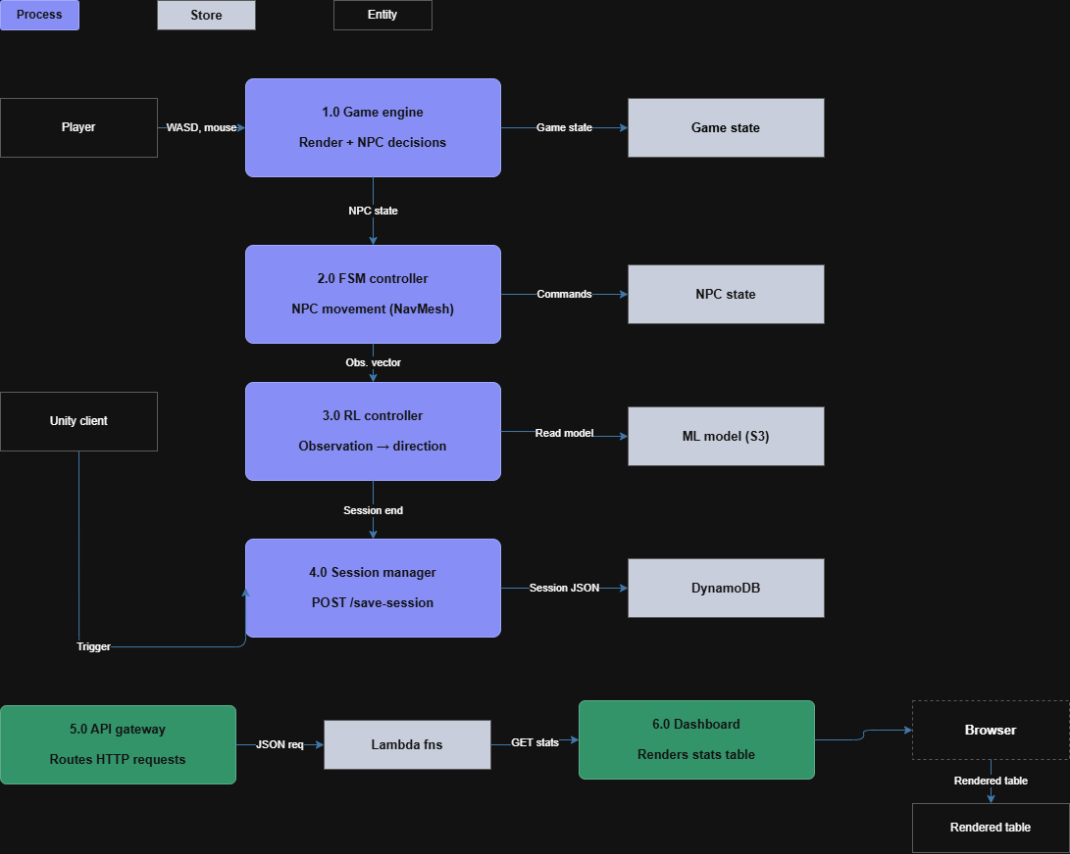
Figure 6 Data Flow Diagram

4.4.2 System Sequence Model

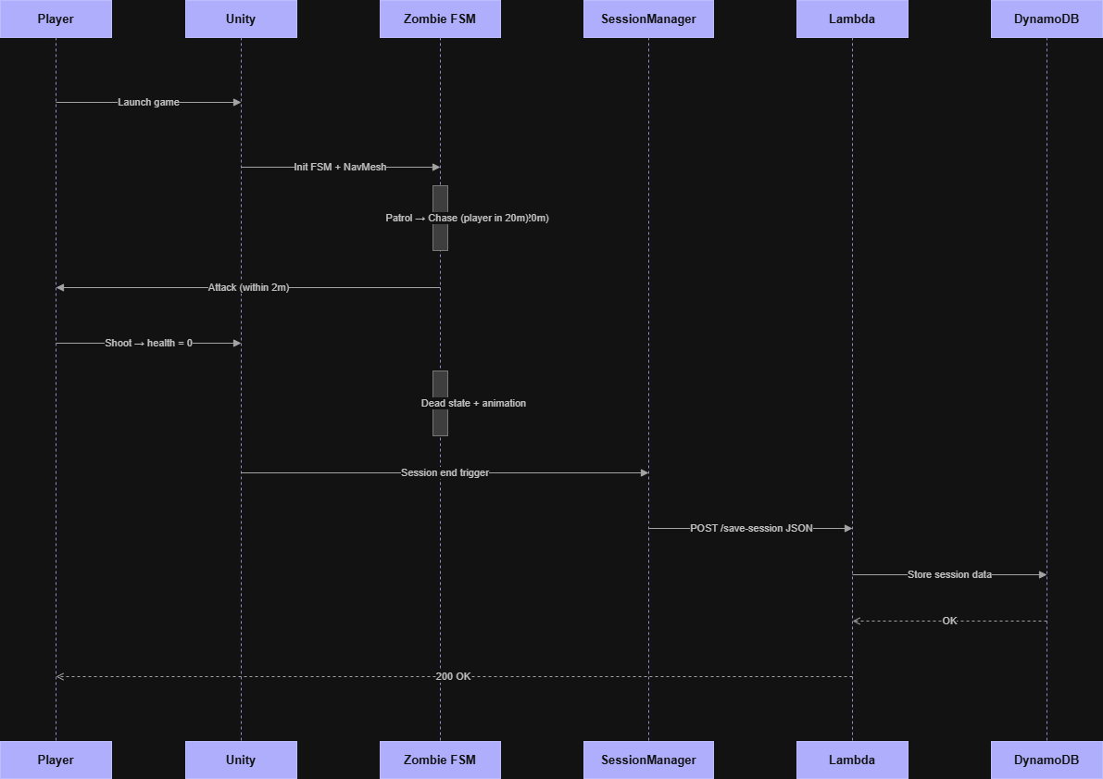
Figure 7 System Sequence Diagram

4.5 Object Models

4.5.1 State Model

The Zombie NPC uses a Finite State Machine having the following five states. It is also notable that the Reinforcement Learning is applied only to decide the direction and speed of movement in the Chase and Patrol states. FSM control is in charge of all state transitions, attack logic, damage handling and death behavior.

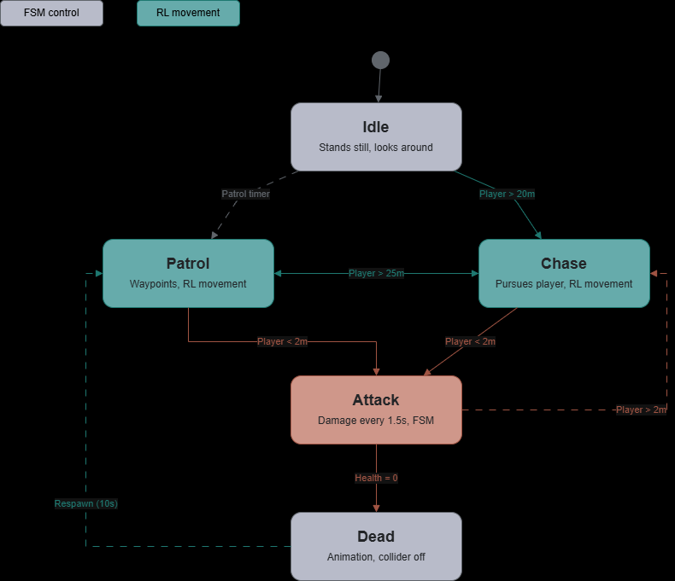
Figure 8 State Diagram

4.5.2 Class Inheritance Model

The relationships between the key classes in the Unity implementation are as follows:

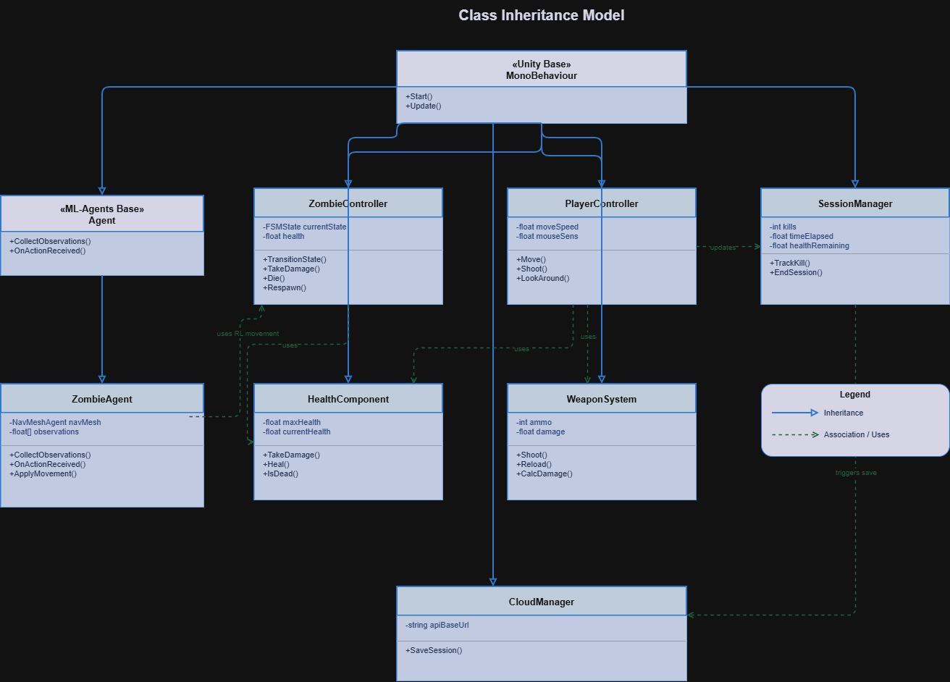
Figure 9 Class Inheritance Diagram

4.6 Implementation Languages

Language | Version | Usage
C# | 9.0 (.NET Standard 2.1) | Unity game logics: FSM, ML-Agents, cloud API call, player controller
Python | 3.8 | Flask REST API back end running on AWS Lambda using Zappa
HCL (Terraform) | 1.x | Infrastructure as Code: S3 bucket, DynamoDB table, public access setting
HTML/CSS/JavaScript | HTML5 / ES6 | S3-hosted, API-fetched, dashboard on a static site
JSON | RFC 8259 | Request/response format of API between Unity and Flask back-end

4.7 Required Support Software

Software | Version | Purpose | License
Unity 3D | 2021.3 LTS | Game engine, 3D environment, physics, NavMesh, animation | Personal (Free)
Unity ML-Agents | Release 20 | Reinforcement learning agent in training NPC movement | Apache 2.0
Python | 3.8.x | Flask API and Zappa deployment tool runtime | PSF License
Flask | 3.0.3 | Lightweight web framework REST API Lightweight web framework | BSD License
boto3 | 1.37.38 | Python SDK to operate with DynamoDB and S3 | Apache 2.0
Zappa | 0.59.0 | AWS Lambda deployment tool written in Python Serverless | MIT License
Terraform | 1.x | AWS resource provisioning infrastructure as Code tool | BSL 1.1
AWS CLI | 2.x | Aws service management Command line interface | Apache 2.0
Visual Studio Code | Latest | Python backend development IDE | MIT License
Visual Studio 2022 | Community | C# Unity script development IDE | Free (Community)

Chapter 5: User Interface Design

5.1 User Interface Specification
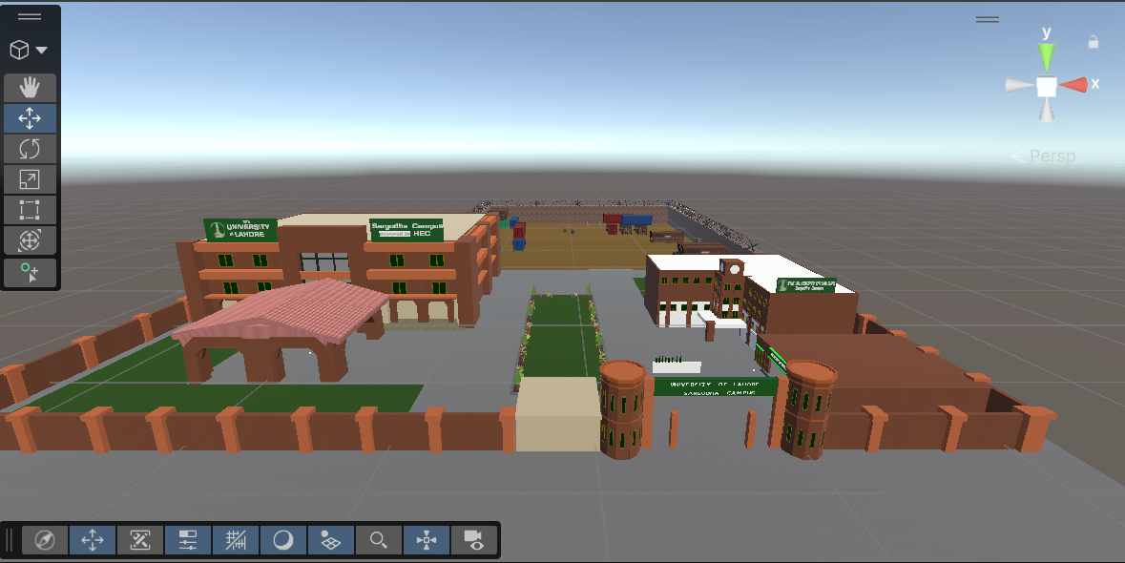
Figure 10 Game Interface-1

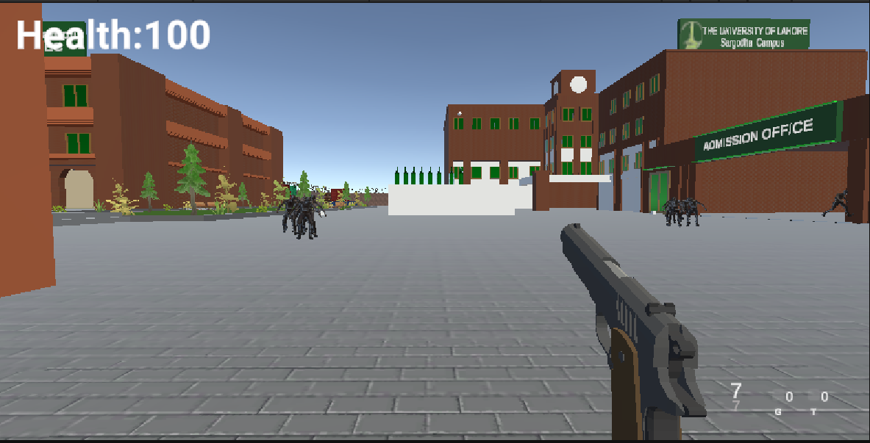
Figure 11 Game Interface-2
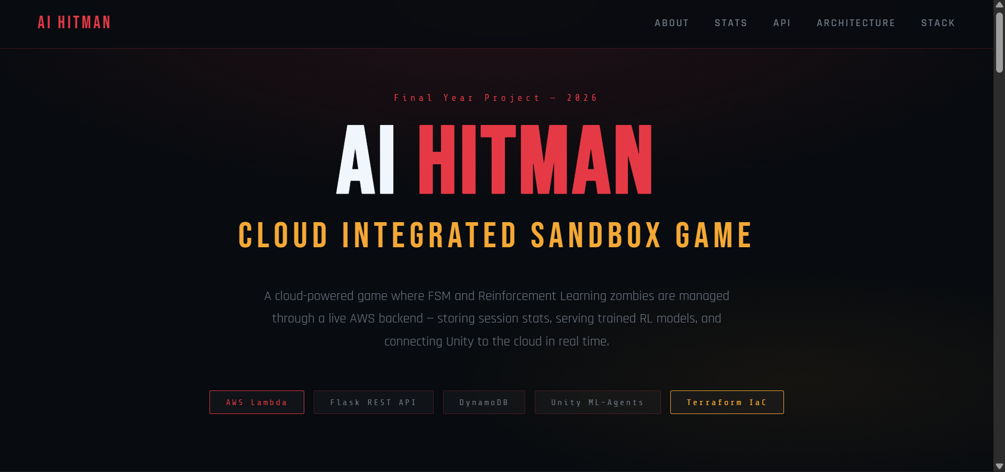
Figure 12 Website Interface

5.1.1 User Interface Design

The in-game HUD is the main user interface and is designed to be minimal and non-intrusive, providing only essential information to the player during gameplay. All HUD elements use a dark semi-transparent background to remain readable across different environment lighting conditions.

UI Element | Position | Content | Update Frequency
Health Bar | Bottom-left corner | Horizontal bar with present player health (0-100%) | Real-time (per frame)
Kill Counter | Top-right corner | Integer number of zombies killed during this session | On a kill event
Session Timer | Top-center | Time elapsed MM:SS format | Each second
Crosshair | Screen center | Weapon aiming crosshair that is stationary | Static
Ammo Counter | Bottom-right corner | Current ammo / total ammo available | Each time that a shot is fired
Damage Indicator | Screen edges | Red flash overlay on taking damage by player | On damage event

5.1.2 Report Format/Sample Data

Website Dashboard Interface
The project dashboard is a simple site that is under AWS S3 and can be accessed at:
http://hitman-npc-data.s3-website-us-east-1.amazonaws.com

The dashboard consists of five sections:

Section | Content | Data Source
Hero Section | Project title, subtitle, badges of the technology | Static HTML
Team Section | Muhammad Abdullah (Cloud), Hassan Saleh Hayat (Unity/ AI), Supervisor Mam Sana Fatima | Static HTML
Live Stats Section | 4 summary cards: Total Sessions, Total Kills, RL Sessions, FSM Sessions + session table | GET /get-stats API
API Endpoints Section | All 5 live endpoints with method, path, description, and live URL | Static HTML
Architecture Section | Unity -Flask API -DynamoDB -S3 flow diagram | Static HTML
Tech Stack Section | 8 technology cards: AWS, Lambda, DynamoDB, S3, Flask, Terraform, Unity, ML-Agents | Static HTML

API Response Formats
Sample answer to the GET /get-stats endpoint:
{“sessions": [{“player_id": "player1", "kills": 5, "health_left": 75.0, "weapon": "M16", "session_time": 120.5, "ai_type": "FSM", "timestamp": "2026-04-25 15:56:36”}], "total": 1}

5.2 User Support

5.2.1 Online Help material

The game offers simple on-screen control instructions upon entering the game. There is a short control scheme overlay in the first five seconds that shows WASD navigation, mouse control, left-click shoot and right-click aim controls. The overlay will automatically fade in five seconds or when any key is pressed.

5.2.2 Error Conditions and System Messages

Error Condition | System Message | Handling
API unreachable | Unable to save session statistics Will retry | Maximum 3 attempts with delay of 2s
Download of RL model fails | Running with default FSM movement | Goes back to pure FSM movement, play resumes as usual
DynamoDB write timeout | 500 Internal Server Error returned to Unity | Unity catches exception, logs error, session continues
Invalid session data | 400 Bad Request | Missing field name before sending Unity validates data locally
Website statistics loading error | NO DATA YET - SESSIONS will be visible after playing a game | Dashboard shows friendly message, no crash

Chapter 6: System Verification & Validation

6.1 Items and Functions to be Tested

The following functional areas require verification and validation:

Test Area | Components | Test Type
Player Controls | Movement, shooting, aiming, jumping | Functional / Manual
FSM State Transitions | Idle → Patrol → Chase → Attack → Dead | Functional / Manual
RL Movement | Model inference, movement output application | Functional / Observation
FSM-RL Integration | RL controls movement, FSM controls all other behaviors | Integration
Cloud API - /ping | GET endpoint response | API / Automated
Cloud API - /save-session | POST with valid and invalid data | API / Automated
Cloud API - /get-stats | GET returns all sessions from DynamoDB | API / Automated
Cloud API - /upload-model | POST multipart file upload to S3 | API / Manual
Cloud API - /get-model-url | GET presigned URL generation | API / Manual
Website Dashboard | Stats loading, table rendering, refresh button | UI / Manual
End-to-End Flow | Game session → API call → DynamoDB → Dashboard display | Integration

6.2 Description of Test Cases

Test ID | Test Case | Input | Expected Output | Pass Criteria
TC-01 | Health Check API | GET /ping | {"status":"ok","message":"Hitman API is running"} | HTTP 200, correct JSON
TC-02 | Save Valid Session | POST /save-session with all required fields | {"status":"session saved"} | HTTP 200, data appears in DynamoDB
TC-03 | Save Invalid Session | POST /save-session missing kills field | {"error":"Missing field: kills"} | HTTP 400, correct error message
TC-04 | Get All Stats | GET /get-stats after saving sessions | JSON with sessions array and total count | HTTP 200, all saved sessions returned
TC-05 | FSM Patrol State | Player outside 20m detection range | Zombie moves between waypoints | Zombie follows NavMesh path
TC-06 | FSM Chase State | Player enters 20m detection range | Zombie navigates toward player | NavMesh path updates to player position
TC-07 | FSM Attack State | Player within 2m of zombie | Player health decreases every 1.5s | Health bar reduces correctly
TC-08 | FSM Death State | Zombie health reaches 0 | Death animation, respawn after 10s | Animator plays death clip
TC-09 | RL Movement Active | useRL = true in ZombieAgent | RL model outputs movement, FSM handles rest | Movement controlled by model
TC-10 | RL Fallback | Model download fails | FSM handles all movement | Game continues without crash
TC-11 | End-to-End Session | Complete game session | Stats appear on website dashboard | Dashboard table shows new row
TC-12 | Float Data Type | session_time = 120.5 (float) | Stored as Decimal in DynamoDB | No TypeError exception

6.3 Justification of Test Cases

TC-01 to TC-04 test the cloud API layer the heart of the cloud integration that all the endpoints properly process valid and invalid inputs and do not corrupt data in DynamoDB.
TC-05-TC-08 are a complete validation of the FSM state machine, with each state and transition being tested separately. These are very important to the gameplay because FSM determines all non-movement zombie actions (attack, damage, death, respawn), which are essential to the proper functioning of the game. RL integration is validated by TC-09 and TC-10. TC-09 verifies that the ML-Agents model can be controlled when useRL is on and TC-10 that a model download failure does not crash the game. TC-11 confirms the entire end to end flow of game to the cloud to dashboard. TC-12 came about following a DynamoDB float type bug experienced in the development, which confirmed the Decimal conversion bug.

6.4 Test Run Procedures and Results

Test ID | Procedure | Actual Result | Status
TC-01 | Run: Invoke-WebRequest /ping | {"message":"Hitman API is running","status":"ok"} HTTP 200 | PASS
TC-02 | Run: Invoke-WebRequest /save-session with full JSON body | {"status":"session saved"} HTTP 200, record in DynamoDB confirmed | PASS
TC-03 | Run: POST /save-session without kills field | {"error":"Missing field: kills"} HTTP 400 | PASS
TC-04 | Run: GET /get-stats after TC-02 | Sessions array with 1 entry, total: 1 | PASS
TC-05 | Observe zombie behavior when player far away | Zombie patrolled between waypoints using NavMesh | PASS
TC-06 | Walk player within 20m of zombie | Zombie immediately began chasing player | PASS
TC-07 | Stand next to zombie without shooting | Player health decreased in 1.5s intervals | PASS
TC-08 | Shoot zombie until health = 0 | Death animation played, zombie respawned after 10s | PASS
TC-09 | Enable useRL flag, observe movement | ML model-controlled movement direction and speed | PASS
TC-10 | Disable network, start game | Game launched, FSM movement used as fallback | PASS
TC-11 | Play session, check website dashboard | New session row appeared in dashboard stats table | PASS
TC-12 | POST session_time as float 120.5 | No TypeError, stored correctly as Decimal in DynamoDB | PASS

The 12 test cases were all successfully passed. The system fulfills all the functional requirements outlined in Chapter 2. The test only had the problem of the DynamoDB float type error (TC-12), which was solved by converting float numbers to Python Decimal type and then inserting them into DynamoDB.

Chapter 7: Conclusions

7.1 Summary

The project is a combination of game development, AI, and cloud computing into a unified system. AI Hitman is a 3D sandbox game with zombie NPCs, which have a Finite State Machine to control their behavior and a Reinforcement Learning model to decide their movement. The cloud backend, which is developed based on AWS Lambda and Flask REST API, delivers five live endpoints to deliver models, store sessions, and retrieve statistics. The most important technical accomplishment is the hybrid AI structure: RL is used to control zombie movement (direction and speed) and FSM controls all other behaviors state transitions, damage, attack patterns, and death/respawn logic. This is a way to maximize the strengths of both models; RL is based on adaptive movement and FSM on deterministic behavioral control. All AWS resources (S3, DynamoDB, access policies) are configured through Terraform, which can be completely reconfigured within less than two minutes. Flask API is deployed on AWS Lambda serverlessly using Zappa, offering a production-grade REST API at no charge in the AWS Free Tier. A project site deployed on S3 is a live dashboard showing real-time player session statistics on DynamoDB, a presentation tool and a practical monitoring interface.

7.2 Problems Encountered and Solved

Problem | Root Cause | Solution Applied
DynamoDB float type error | Python float type not supported by boto3 DynamoDB serializer | Converted all float values to Python Decimal type before insertion using str() conversion
Zappa troposphere compatibility error | troposphere 4.10.1 used Python 3.10+ syntax incompatible with Python 3.8 | Downgraded troposphere to version 3.2.2 which supports Python 3.8
PowerShell JSON policy error | PowerShell escapes backslashes in inline JSON strings differently than bash | Created policy.json file using Python json.dump() to avoid shell escaping issues
Zappa virtual environment error | Zappa requires an active virtualenv; global Python install not supported | Created venv, activated with venv\Scripts\activate, reinstalled all dependencies
AWS credential error in Flask | Flask was loading credentials from old project's cached credentials instead of .env | Set AWS credentials explicitly in .env file and verified with aws sts get-caller-identity
S3 website 403 Forbidden error | S3 bucket had Block Public Access enabled by Terraform configuration | Removed public access block with aws s3api delete-public-access-block, applied bucket policy via Python-generated JSON file
RL and FSM integration scope | Initially unclear which behaviors RL should control | Agreed that RL controls only movement output; all FSM state transitions and behaviors remain unchanged

7.3 Suggestions for Better Approaches

With the advantage of hindsight, the following improvements can be made to the current approach:

- AWS CDK or SAM should be used in Python-based workflows rather than Terraform because these tools merge more effectively with Lambda deployment workflows and lessen the quantity of distinct tools needed.
- Initial deployment of the S3 website with HTTPS: When establishing CloudFront distribution, configure it to use CloudFront distribution, and do not take any additional steps to configure public access.
- Create a virtual environment at the initial stages of the development process instead of installing packages on a global scale first, which will prevent conflicts over credentials and dependencies among projects.
- All configuration (region, bucket name, table name) in the codebase should be configured using environment variables at the outset, instead of hardcoded values that are later to be changed. Repeat: Train the RL model using a fixed random seed to make the training process reproducible and record the training hyperparameters in a YAML configuration file under version control.

7.4 Suggestions for Future Extensions

The existing implementation has a solid basis to several extensions of significance:

- Multiplayer Support: Add WebSocket support to the cloud backend through AWS API Gateway WebSocket APIs to support real-time multiplayer sessions in which multiple players can share the same game world.
- Leaderboard System: Add a /get-leaderboard endpoint returning the top players based on number of kills or number of points in a session, and displaying a real-time competitive leaderboard on the dashboard.
- The proposed ideas can be summarized as follows:<|human|>1. Continuous RL Training: Have a feedback loop, whereby session data stored in DynamoDB is continuously used to retrain the RL model, allowing the zombie AI to continually improve based on actual player behaviour.
- Advanced RL Scope: Extend RL control to non-moving tasks, such as timing of attacks and cover-seeking behaviour, but use FSM to manage high-level states.
- Mobile Platform: Develop an implementation of the game in Unity WebGL or a native mobile platform so that players can play without having to install a Windows PC.
- CI/CD Pipeline: Automatically run tests and deploy API updates with Zappa through GitHub Actions each time some code is added to the main branch and allow continuous deployment.
- Analytics Dashboard: Add to the website dashboard Chart.js visuals that display kills per time, FSM vs RL comparison charts, weapon usage statistics.

Bibliography and References

Juliani, A., Berges, V., Vckay, E., Gao, Y., Henry, H., Mattar, M., & Lange, D. (2018). Unity: Intelligent agents in general. arXiv preprint arXiv:1809.02627.

I Millington & J. Funge. (2009). Games Artificial Intelligence (2nd Ed.). CRC Press.
Mnih, V., Kavukcuoglu, K., Silver, D., Rusu, A. A., Veness, J., Bellemare, M. G., ... & Hassabis, D. (2015). Control of up to the human level, using deep reinforcement learning. Nature, 518(7540), 529-533.

Russell, S., & Norvig, P. (2020). Artificial Intelligence: A Modern Approach (4th Edition). Pearson Education.

Schulman, J., Wolski, F., Dhariwal, P., Radford, A., & Klimov, O. (2017). Algorithms for proximal policy optimization. arXiv preprint arXiv:1707.06347.
Sutton, R. S., & Barto, A. G. (2018). A second edition of Reinforcement Learning: An introduction. MIT Press.

Vinyals, O., Babuschkin, I., Czarnecki, W. M., Mathieu, M., Dudzik, A., Chung, J., ... & Silver, D. (2019). Multi-agent reinforcement learning to become Grandmaster in StarCraft II. Nature, 575(7782), 350-354.

Unity Technologies. (2023). Documentation for the Unity ML-Agents toolkit. Retrieved from https://github.com/Unity-Technologies/ml-agents Amazon Web Services. (2023). AWS documentation. Retrieved from https://docs.aws.amazon.com/

Amazon Web Services. (2023). AWS documentation. Retrieved from https://docs.aws.amazon.com/

HashiCorp. (2024). Terraform documentation. Retrieved from https://developer.hashicorp.com/terraform/docs

Pallets Projects. (2024). Flask documentation. Retrieved from https://flask.palletsprojects.com/

Amazon Web Services. (2024). boto3 documentation. Retrieved from https://boto3.amazonaws.com/v1/documentation/api/latest/index.html

